7.80: (a)
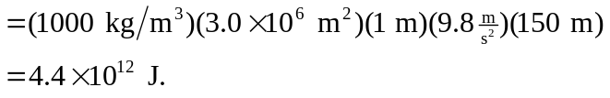

(b) 90% of the stored energy is converted to electrical energy, so

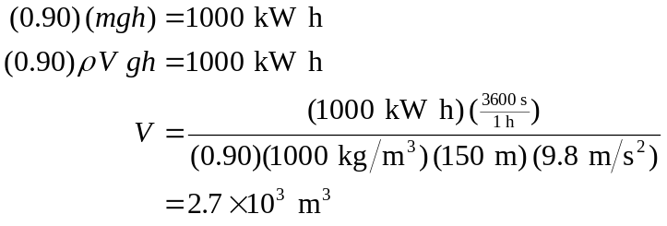

Change in level of the lake:
